Mirror-Touch Synesthesia

🪞✋ What is Mirror-Touch Synesthesia?
# Source: AI Source: Provided by: [Data Path: Persons Table -> ID Column: 1, Name_En Column: Motasem Essam] -> From: [Chatgpt (GPT-4-turbo)] on [7/24/2025]
Mirror-touch synesthesia is a rare neurological condition in which a person feels physical sensations on their own body when they see someone else being touched — as if the touch were happening to them.

📘 Definition:
# Source: AI Source: Provided by: [Data Path: Persons Table -> ID Column: 1, Name_En Column: Motasem Essam] -> From: [Chatgpt (GPT-4-turbo)] on [7/24/2025]
Mirror-touch synesthesia is a form of synesthesia in which seeing another person being touched triggers the feeling of touch on the same part of the synesthete’s body.

🔍 How It Works:
# Source: AI Source: Provided by: [Data Path: Persons Table -> ID Column: 1, Name_En Column: Motasem Essam] -> From: [Chatgpt (GPT-4-turbo)] on [7/24/2025]
- If a synesthete sees someone being tapped on the left shoulder, they might feel a tap on their own left shoulder.
- If they watch someone get a needle in the arm, they might feel a mild prick or pressure in the same area.
The response is involuntary and automatic, not imagined or chosen.

🧠 Why It Happens:
# Source: AI Source: Provided by: [Data Path: Persons Table -> ID Column: 1, Name_En Column: Motasem Essam] -> From: [Chatgpt (GPT-4-turbo)] on [7/24/2025]
- Everyone has mirror neurons — brain cells that activate when we see someone else perform an action or feel an emotion.
- In mirror-touch synesthetes, this system may be overactive, causing the brain to treat observed touch as self-touch.
- There is increased activity in the somatosensory cortex, the part of the brain responsible for physical sensation.

🔬 Scientific Features:
# Source: AI Source: Provided by: [Data Path: Persons Table -> ID Column: 1, Name_En Column: Motasem Essam] -> From: [Chatgpt (GPT-4-turbo)] on [7/24/2025]
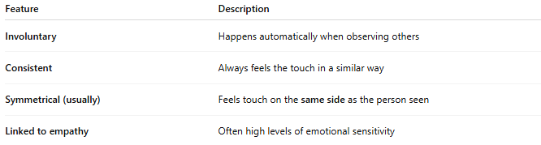
Feature | Description
Involuntary | Happens automatically when observing others
Consistent | Always feels the touch in a similar way
Symmetrical (usually) | Feels touch on the same side as the person seen
Linked to empathy | Often high levels of emotional sensitivity

👥 Example Situations:
# Source: AI Source: Provided by: [Data Path: Persons Table -> ID Column: 1, Name_En Column: Motasem Essam] -> From: [Chatgpt (GPT-4-turbo)] on [7/24/2025]

What They See | What They Feel
Someone hugs another person | A light pressure or warmth on their own chest or arms
A person gets slapped on the cheek | A light stinging sensation on the same cheek
A child touches their own toes | Tingling in their own toes

📊 Mirror-Touch vs Normal Empathy:
# Source: AI Source: Provided by: [Data Path: Persons Table -> ID Column: 1, Name_En Column: Motasem Essam] -> From: [Chatgpt (GPT-4-turbo)] on [7/24/2025]

Feature | Normal Empathy | Mirror-Touch Synesthesia
Emotional only | Yes | No – also includes physical sensation
Voluntary | Can be controlled | Involuntary and automatic
Tactile feedback | No | Yes — touch is actually felt

✅ Summary:
# Source: AI Source: Provided by: [Data Path: Persons Table -> ID Column: 1, Name_En Column: Motasem Essam] -> From: [Chatgpt (GPT-4-turbo)] on [7/24/2025]
Mirror-touch synesthesia is when watching someone else being touched causes you to feel the same touch on your own body.
It is a rare and powerful example of how sensory and empathetic systems overlap in the brain.

